Yuyi Zhang
Sep 27, 2020
Fall 2020 CPS Quarter
Instructor: Dr. Steward Huang
Module 2:
Classification Using Naive Bayes
ALY 6020_Predictive Analytics

Introduction
In this report, we will employ Naive Bayes algorithm to two datasets. The first one is to classify ham and spam of Short Message Service from our textbook “Machine Learning with R (2015)”. The second one is to classify sentiment of positive or negative from the Roman Urdu corpus. We will apply Naive Bayes related functions to both datasets and evaluate the performance of the classification.

Analysis
The difference between Naive Bayes and k-NN is they are dealing with text content and numeric features, respectively. For numbers, we need to normalize the data. Then they are generally ready to apply on training data. Text contact, on the other hand, will need few more steps in data preparation process. It’ll need to be cleaned by lowering cases, removing numbers, removing stop words, removing punctuation, etc. Then the rest of steps will be similar to k-NN.

Wisconsin Breast Cancer Diagnostic dataset

Step 1 – collecting data
The SMS Spam Collection contains 5,574 records with 2 variables. The first column is type of them SMS, which is the target variable that we are going to predict. The second column is text messages.

Step 2 – exploring and preparing the data
Importing data to the R studio and take a look at the structure.
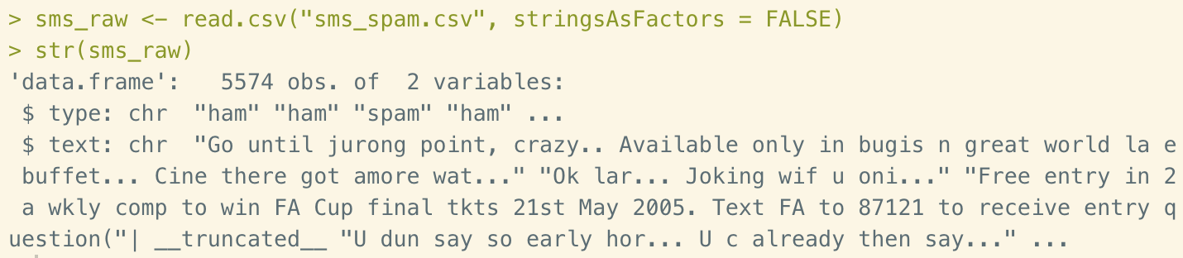
Figure 1. Importing data and structure
Convert the type of text column from “character” to “factor”. Then we how all the records are labeled in this dataset.
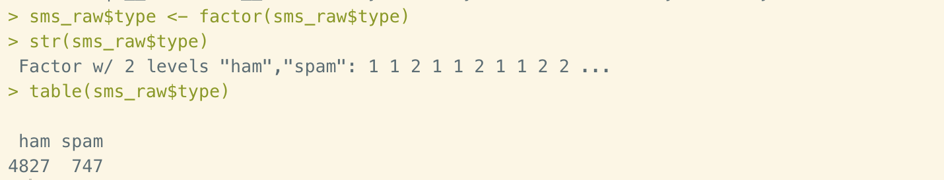
Figure 2. Label summary
Now we are going to clean and standardize the data starting from generate a corpus file of sms raw text. Then we try several different ways to check out the content.
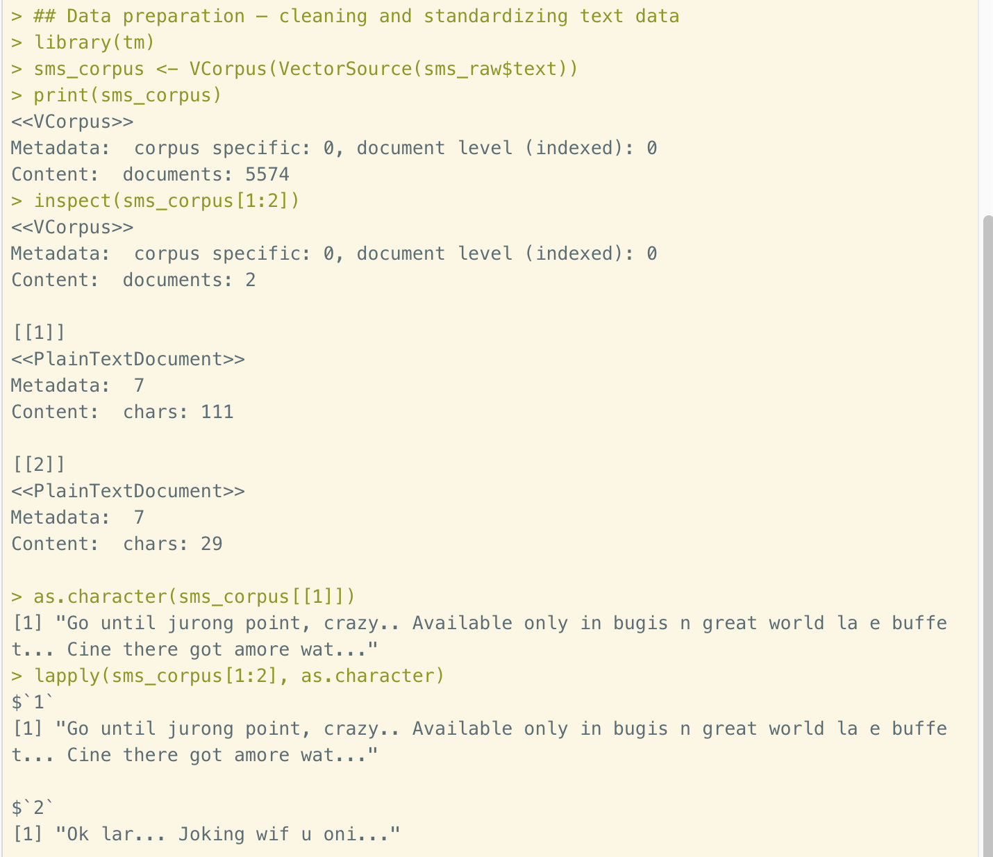
Figure 3. Generate corpus
The next step of data cleaning process is a set of actions, including lowercase, number removal, stop words removal, punctuation removal, performing stemming, and additional whitespace removal. Stop words are the filler words, such as to, and, but, or, etc, which do not provide useful information for text mining. Stemming is the process that only keep the root form of words. The wordstem() function could transform words to the base form. But in this case, we are going to use stemDocument rather than wordstem() to apply this function to the entire corpus of text document. After all the works have been done, we’ve store the data into “sms_corpus_clean”.
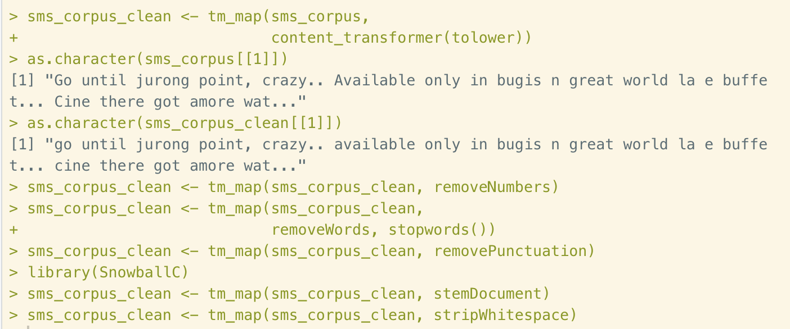
Figure 4. Data cleaning and standardizing
The next step is tokenization. This is a step to split the cleaning message in our corpus into individual words. The result of tokenization is to create a data matrix called Document Term Matrix (DTM) with rows of SMS messages and columns of split words (shown as below). There are numbers in each cell indicating the counting of specified words by the column.
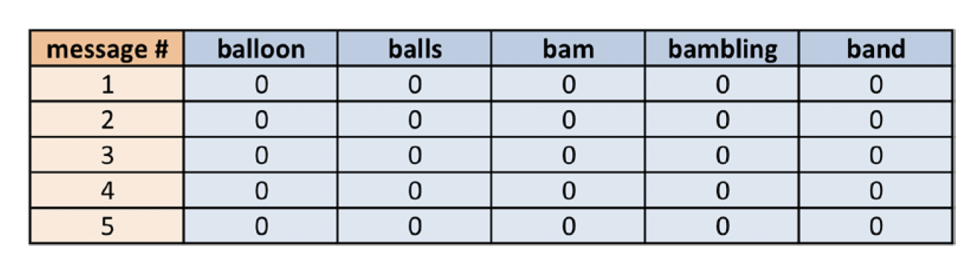
Figure 5. DTM of SMS messages
As we can see that there are many “0”s in this matrix. The fact is that this table is covered by majorities of 0. This is the reason of calling “sparse matrix” of this table.
There is an alternative way to splitting text documents by using a list of control parameter. This is useful if we didn’t perform the cleaning process earlier. There is two ways of tokenization.
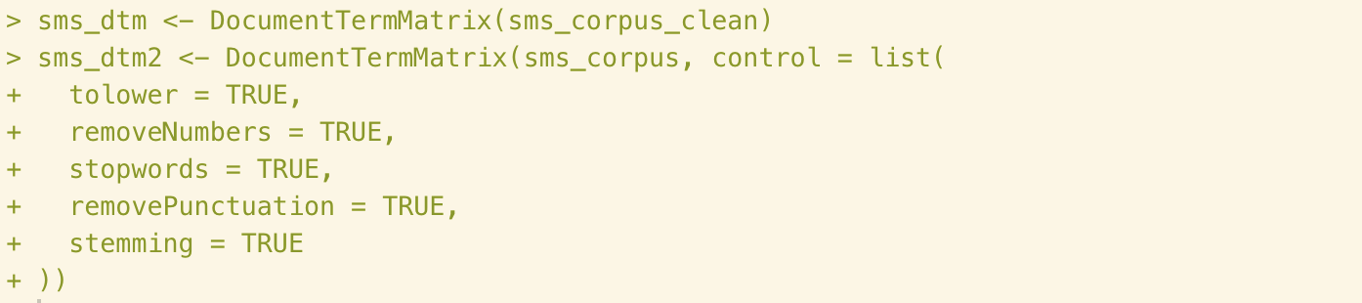
Figure 6. Tokenization
Then let’s compare the results of sms_dtm and sms_dtm2.
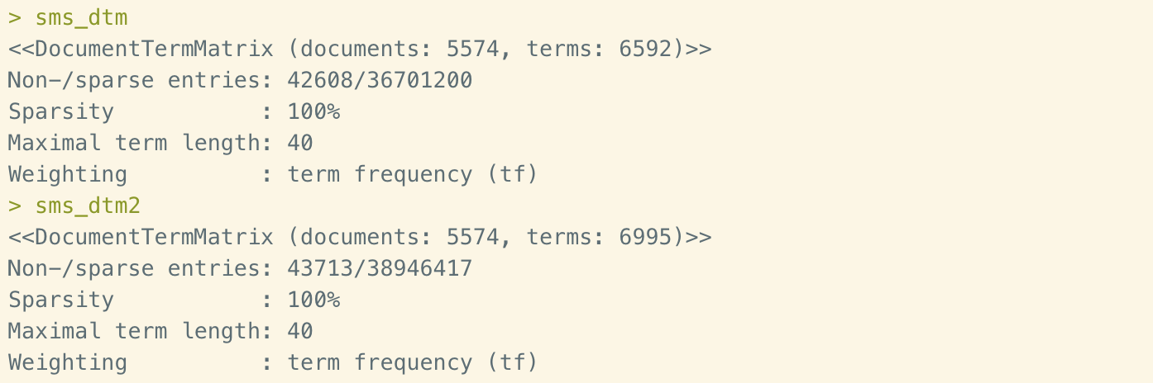
Figure 7. Tokenization results
There are slightly difference between the two results, which is the number of sparse entries. The reason of this discrepancy is that the orders of tokenization are different. After calculation, the stop words are different. Thus, the vectors are slightly different.
Next, we are going to split the entire dataset into two group: 75 % of testing data and 25% of test data. In this example, the first 4,180 are training data. The rest 1,394 records are test data. After dividing, use tables to check the proportion of spam in training and test data. They are both about 13%, which is means that the data are evenly divided.
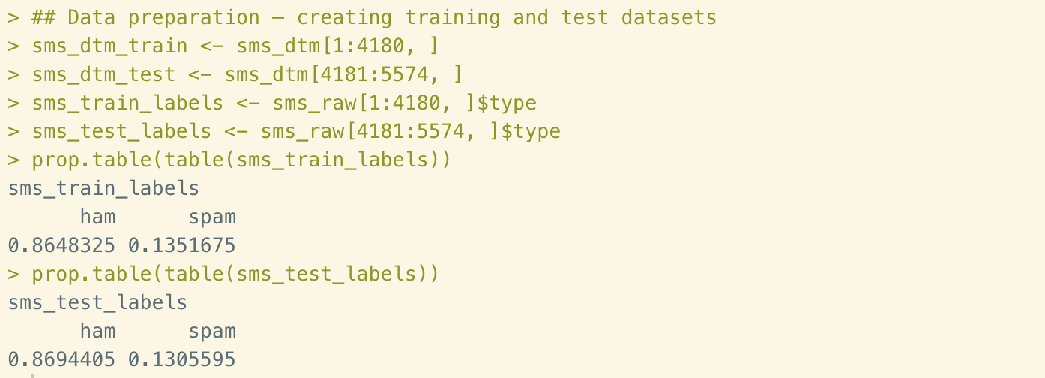
Figure 8. Creating training and test data
There is a visual way to depict the frequency of words in text data, which is word cloud. In this step, we are going to create a word cloud using wordcloud() function.
Figure 9. Creating word cloud
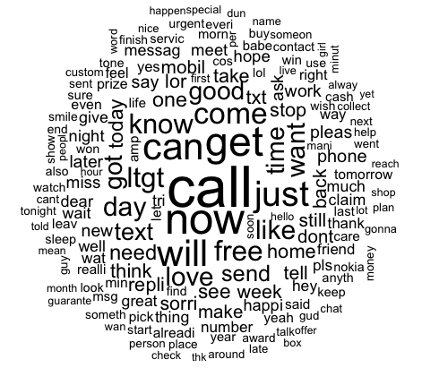
Figure 10. word cloud
This is word frequency of all text massages. We could also get the word cloud for spam and ham message separately.
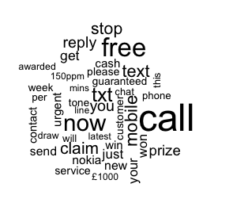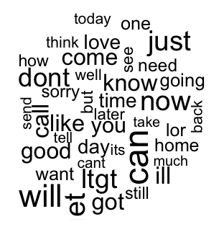
Figure 11. word cloud of spam vs. ham
Now here is the last step of data preparation, reducing the number of features so they will would be better fit for classification.
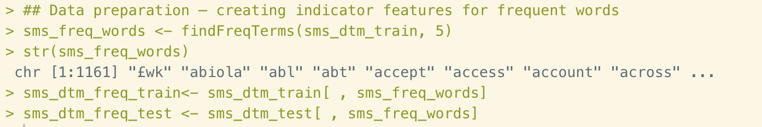
Figure 12. Creating indicator features for frequent words
We eliminate words that appeared less than 5 using findFreqTerms() function. There are now only 1161 features left. Then we restore them into two different vectors. Now let convert the numeric data in these two vectors into categorical features. First, we write a convert_counts function to convert the counts numbers to “Yes” of “No” statements. Then apply the new function to the two vectors to get two new matrixes.
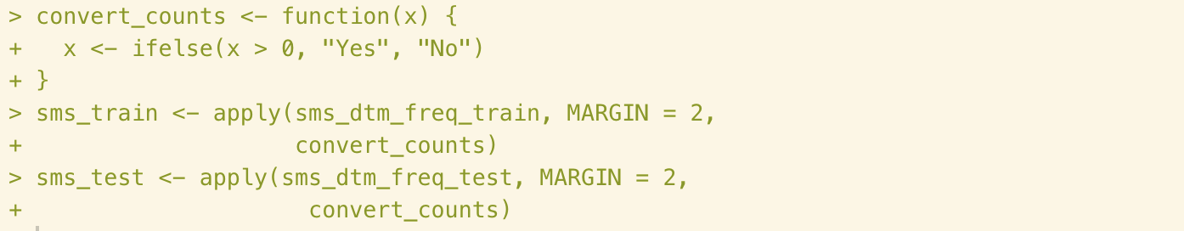
Figure 13. Converting numeric data to categorical features
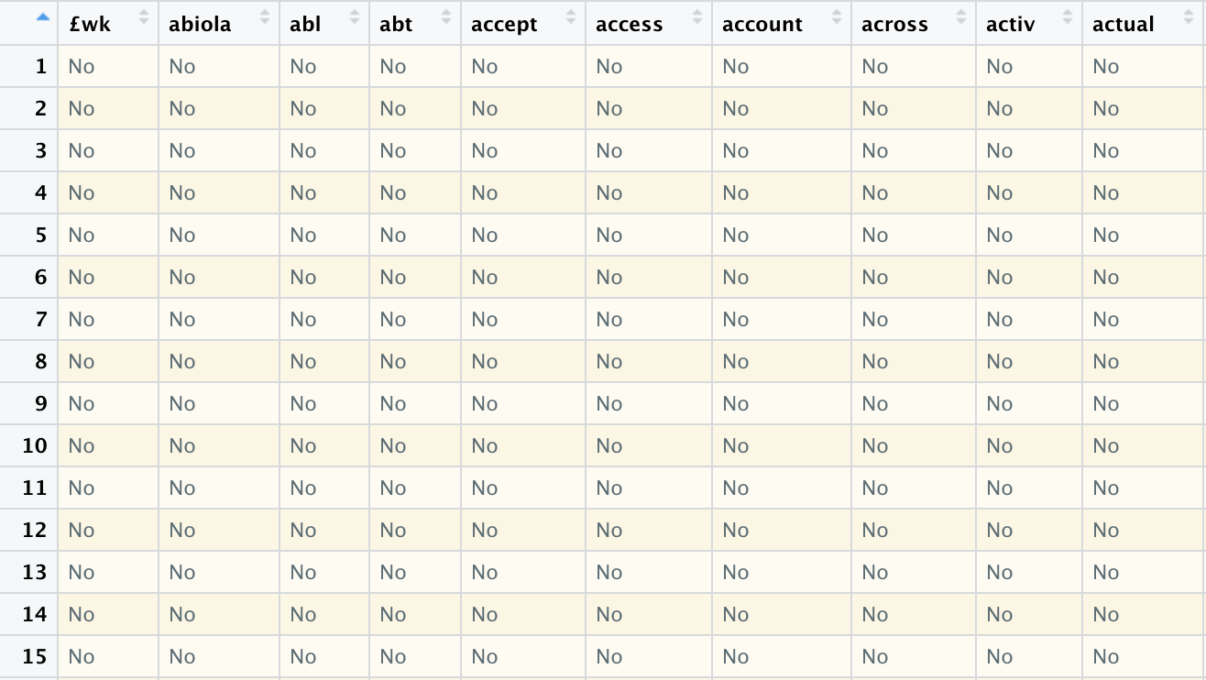
Figure 14. Head of sms_test matrix

Step 3 – training a model on the data
As all the data we need are well prepared, now we could apply the naiveBayes() function to the training data. Naive Bayes is an algorithm that use the frequency of the words to estimate the type of the SMS message (spam or ham). The function of naiveBayes is:
m <- naiveBayes (train, class, laplace = 0)
Figure 15. Training the model

Step 4 – evaluating model performance
After applying the algorithm to SMS, now it’s time to estimate the performance. To do that, first, we need to make the prediction by employing predict() function to the test data. Second, use CrossTable() function to compare.
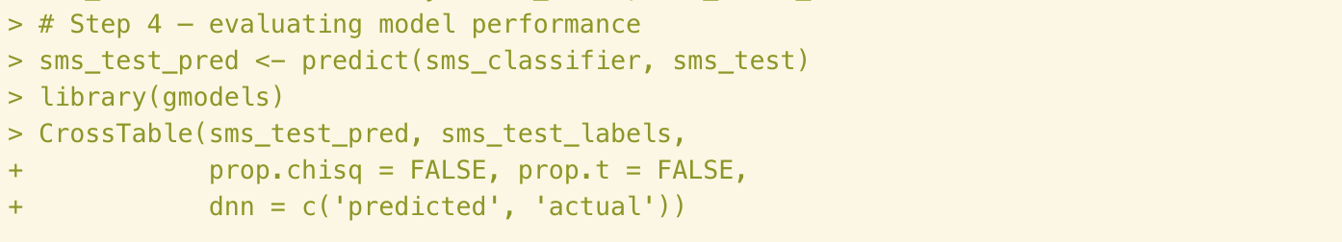
Figure 16. Model evaluation
Here is the generated table:
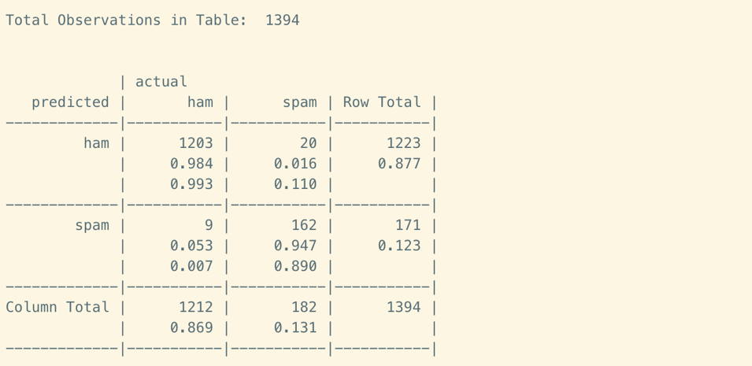
Figure 16. Cross table
There are 1,365 observations out of 1,394 are correctly predicted. For the 29 incorrectly classified records, 9 out of them are false positive. This means that 9 messages would misidentifies as spam but actually they are ham message that might contains important message. But in general, this model performs nearly 98% accuracy, which is very impressive.

Step 5 – improving model performance
For the improving step, we’re going to try adding Laplace estimator to our model with value equals 1.
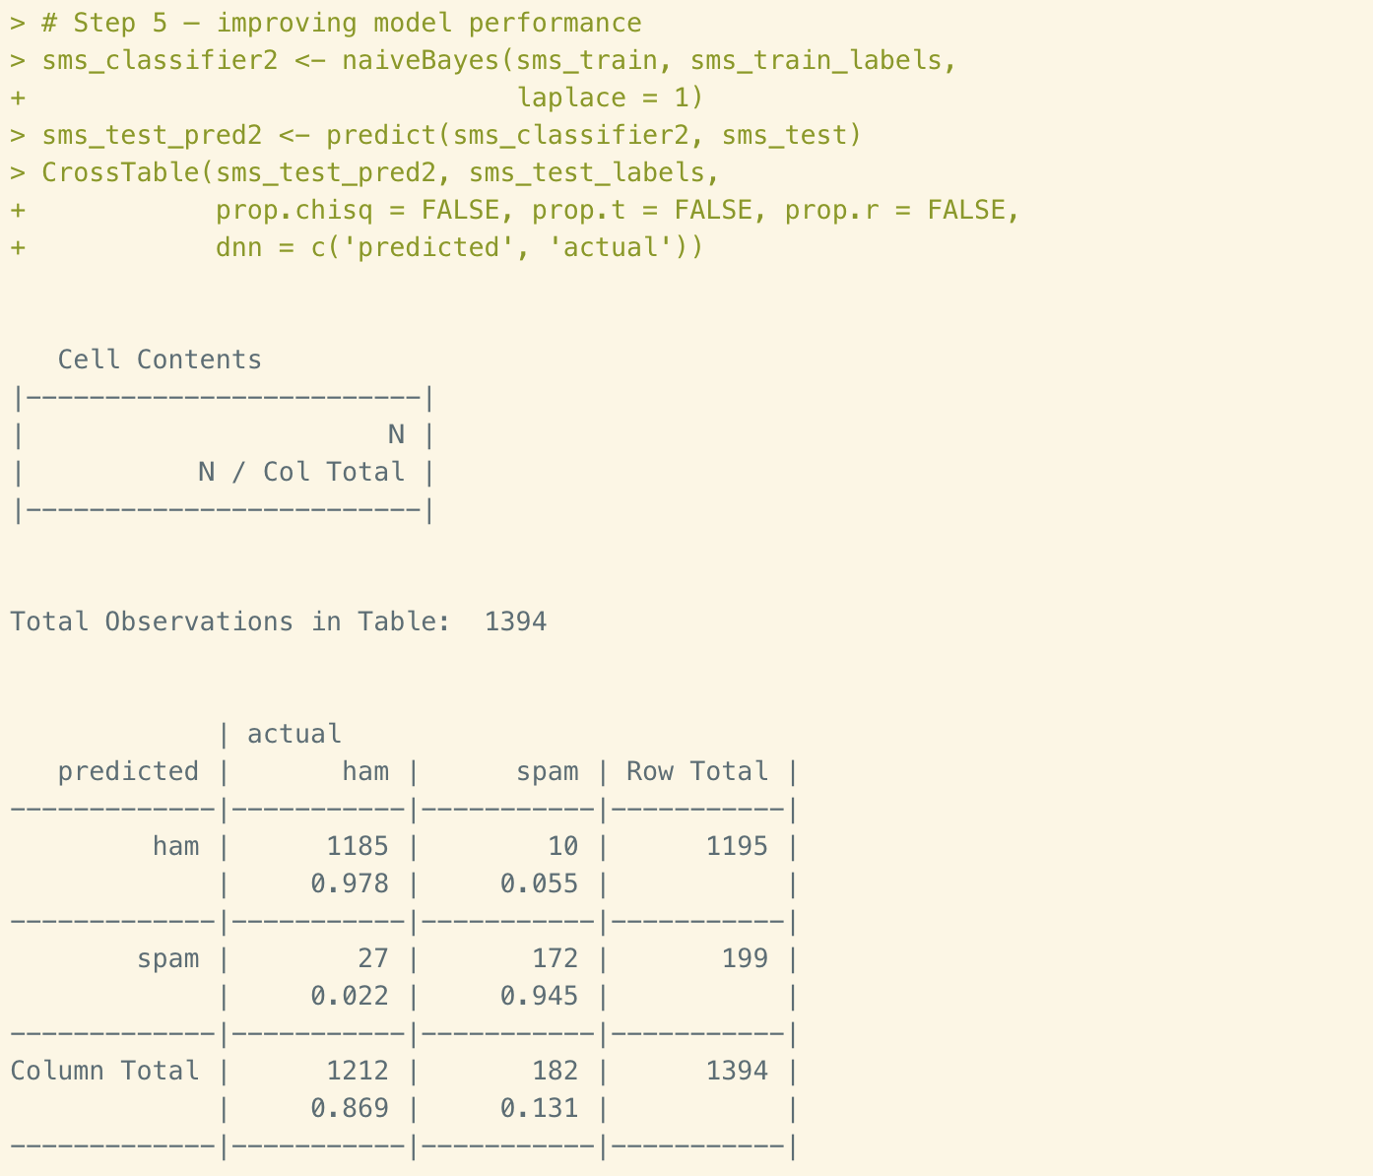
Figure 17. Improving model
From the results table we could see that there are 37 incorrect predictions, which is 8 more than our original model. Therefore, this modification is not accepted.

Roman Urdu Data Set

Step 1 – collecting data
Roman Urdu is a substitution of Urdu language. In this dataset, there are 11,300 observations with 2 variables. The first variable is text comment. The second variable is the sentiment of the comment. We are going to build a model to estimate the sentiment of the comments.

Step 2 – exploring and preparing the data
Import the data into R studio. Then take a look at the data.
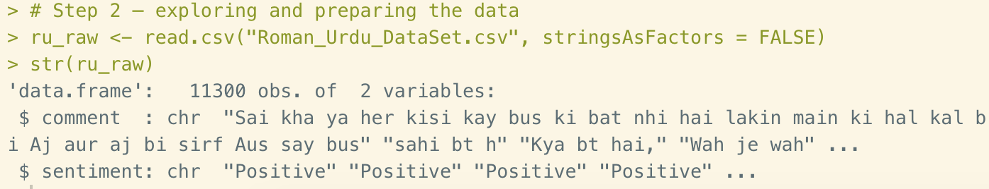
Figure 18. Importing data
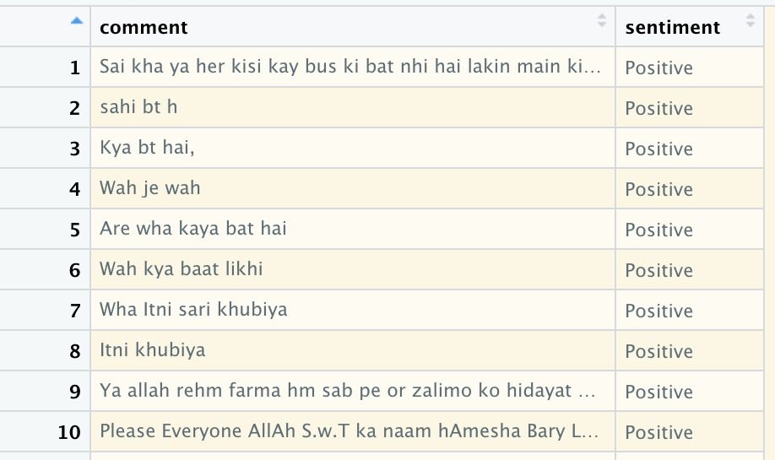
Figure 19. Raw data
There are two type of sentiments in this dataset: Positive and Negative. As we could see that the table was ordered by sentiment, which is not well combined. So, before we start to clean up the data, we need to make all the rows randomly ordered.
Figure 20. Reorder data
This is the results of new matrix.
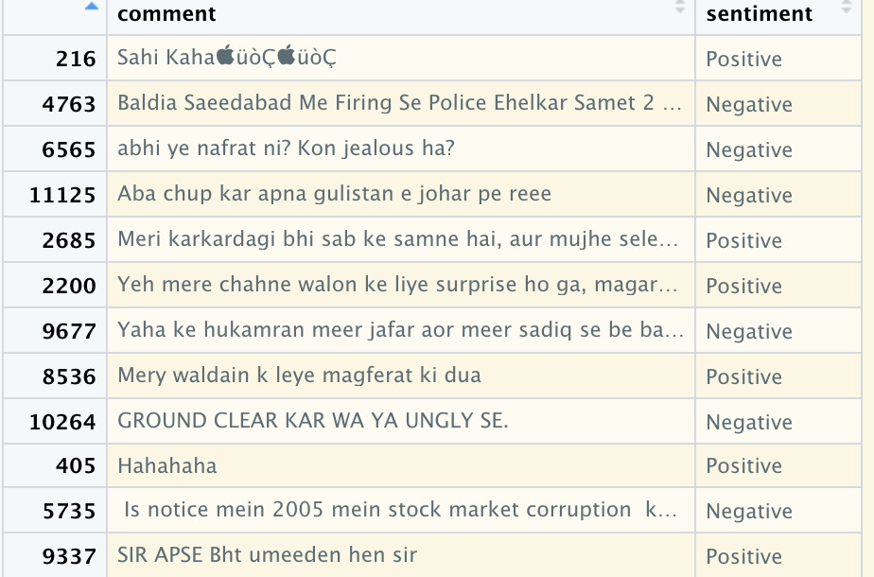
Figure 21. Raw data in randomly order
Convert the data from “character” to “factor” and take a look at the allocation of the two sentiments.
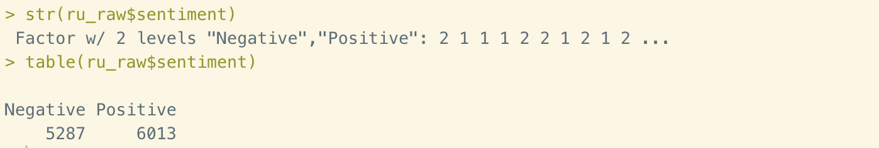
Figure 22. Label summary
Now we could start to clean up the data. First, generate a corpus factor.
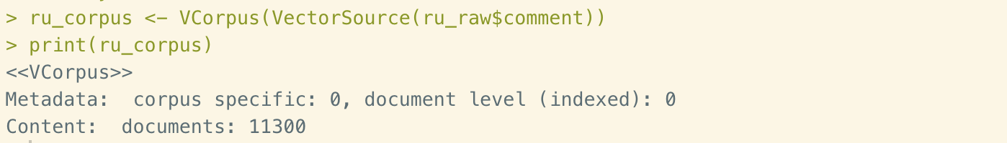
Figure 23. Generate corpus
Second, clean data in following steps: lowercase, number removal, stop words removal, punctuation removal, performing stemming, and additional whitespace removal.
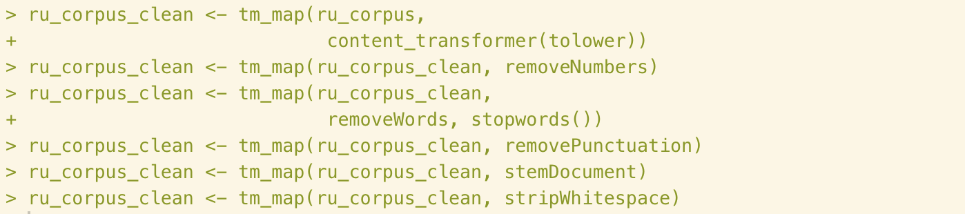
Figure 24. Data cleaning
Third, tokenize the cleaning data. In this step, we are going to split the text content into individual words.
Figure 25. Tokenization
Fourth, splitting the dataset into two part: training data and test data.
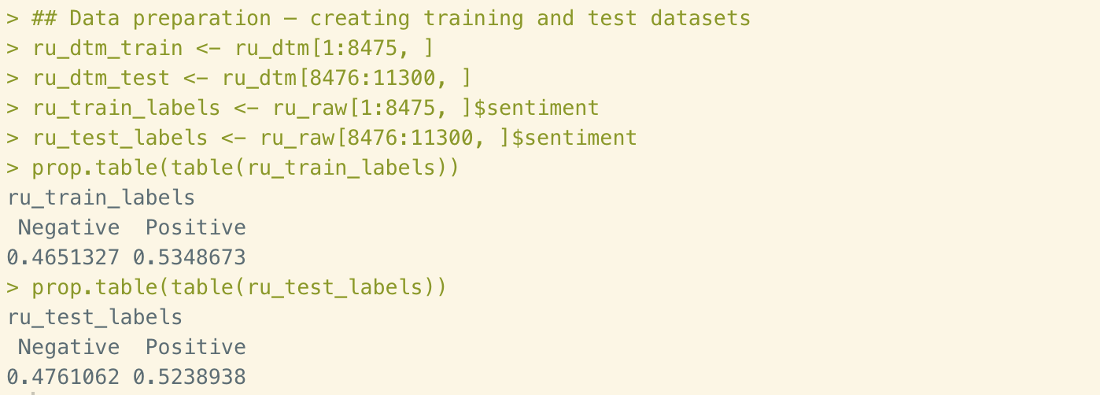
Figure 26. Creating training and test data
Take a look at the proportion of positive sentiment in both training and test dataset, they are all about 53%. It means that the data are evenly divided.
Fifth, create a word clouds of the entire raw dataset.
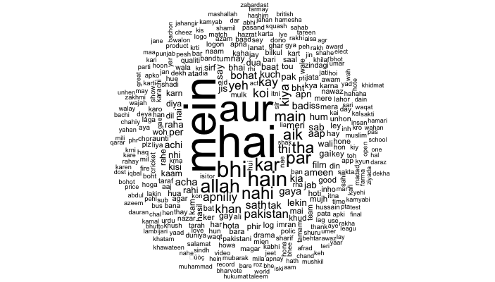
Figure 27. Word cloud
Then we compare the word cloud between positive and negative sentiments.
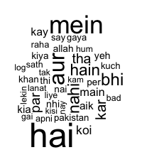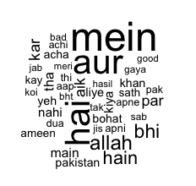
Figure 28. word cloud of negative vs. positive
The last step of data preparation is to reduce the number of features for better useful for the classification.
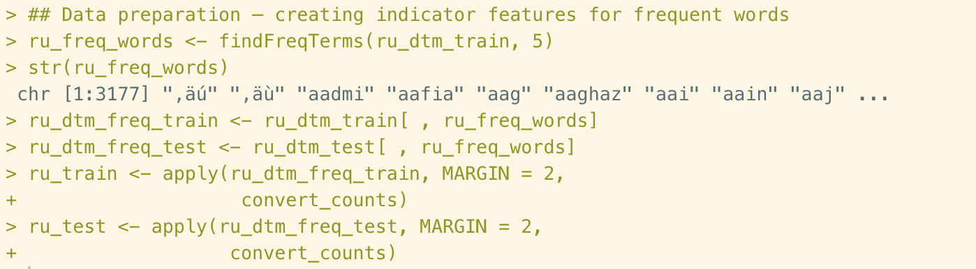
Figure 29. Converting numeric data to categorical features
There is the new matrix we’ve got after conversion.
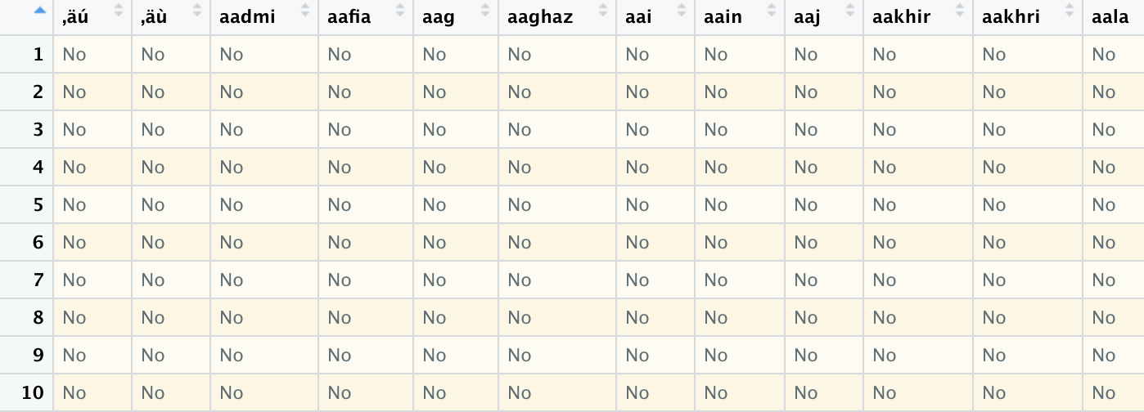
Figure 30. Categorical matrix

Step 3 – training a model on the data
After we’ve got all the data prepared, now let’s apply Naive Bayes algorithm to the dataset.
Figure 31. Perform classify process

Step 4 – evaluating model performance
Now we’ve got our model. let’s test it by predict() function and evaluate the performance by CrossTable() function.
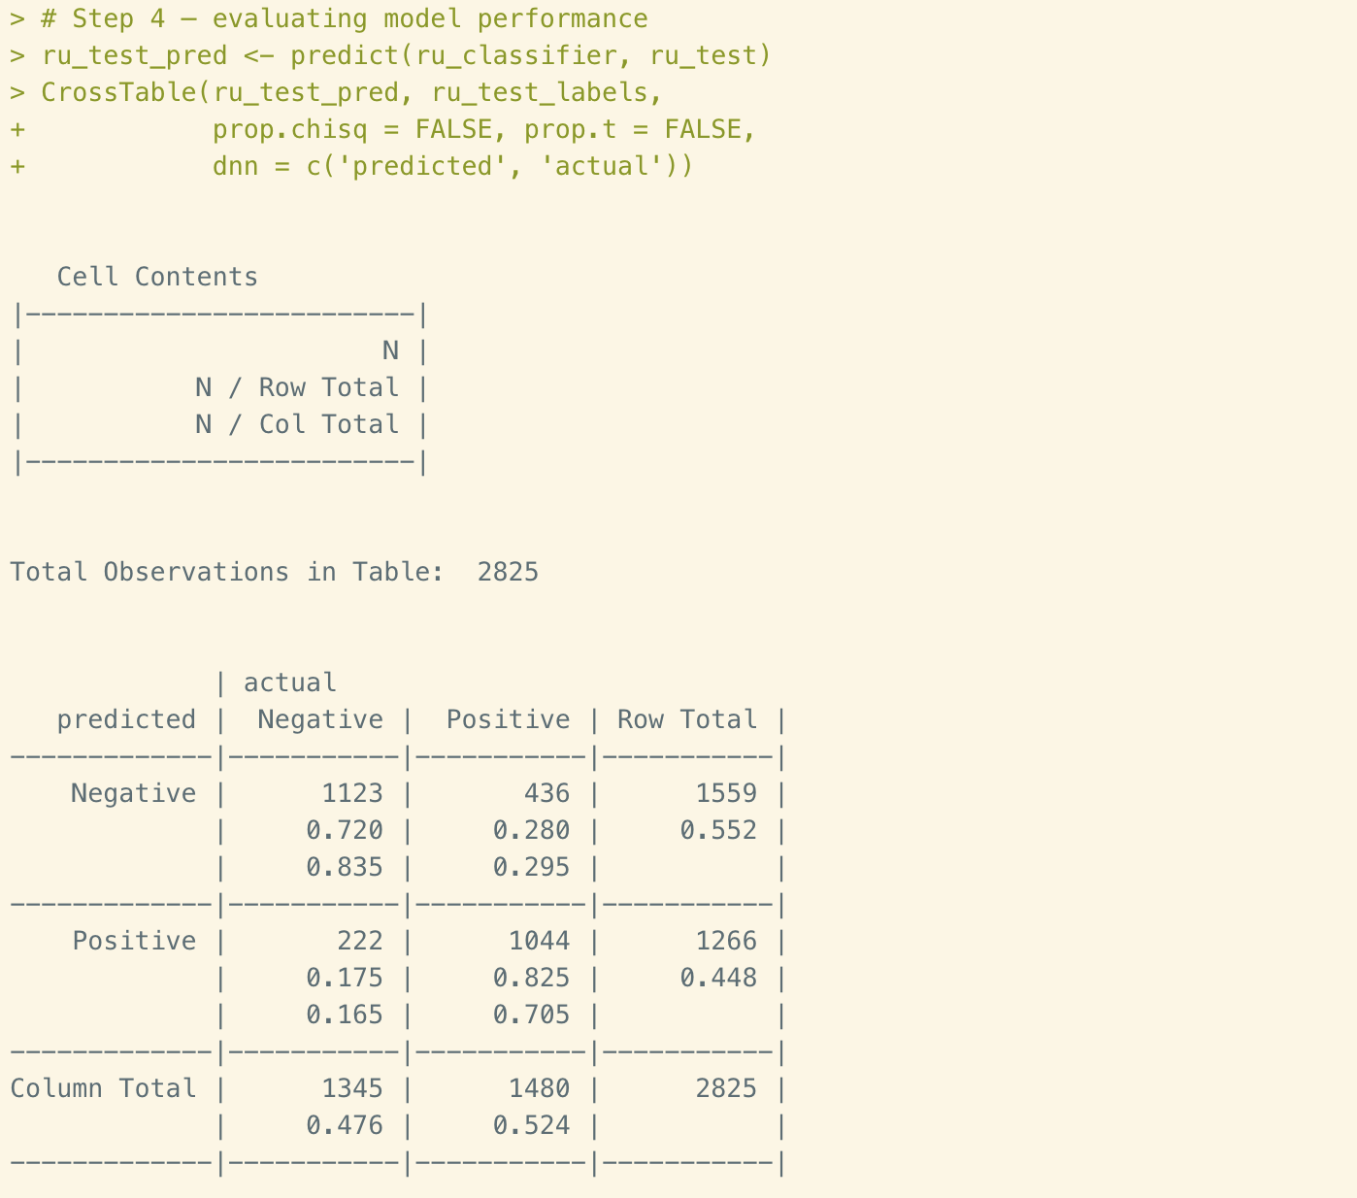
Figure 32. Classifying and evaluating
The results showing that 2,167 out of 2,825 are accurately classified. The accuracy rate is about 76.7%. This is not a satisfied rate that we’re looking for. Let’s try to make some modification next.

Step 5 – improving model performance
In this step, we are going to add Laplace estimator to our model to see if it’ll help to improve the performance.
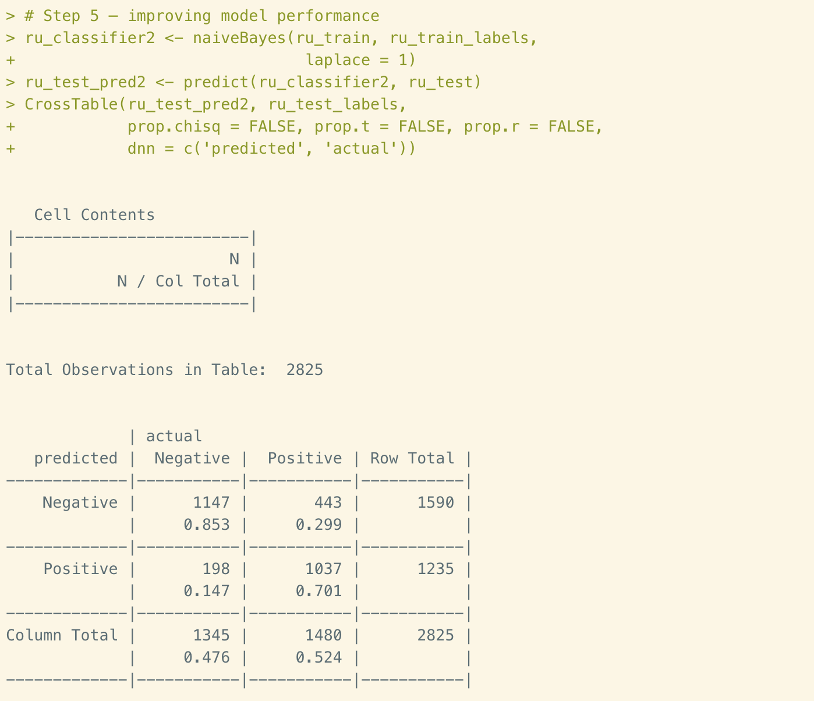
Figure 33. Model improving
The number of correct predictions has been increased from 2,167 to 2,184. But the overall accuracy is still as low as 77.3%. Thinking of the reason for that, the efficiency of stopwords() and stemDocument() might need to be evaluated. This result is telling us that using an English package to analyze a Rome Urdu dataset may not be an ideal solution.

Conclusions
Naive Bayes is an algorism to perform text content classification by using probability to estimate the class of features based on the frequency of word content in training data. Then apply the model to test data for evaluation.
In this report, we use Naive Bayes to classify two sets of datasets. The first one is SMS text messages. We employed Naive Bayes to predict the type of SMS (spam or ham) and got an accuracy more than 98%. The second case is about Rome Urdu language. In this case, our accuracy of predict the sentiments is about 77%. The language is an essential condition of this algorithm.

Reference
- Lantz, B. (July 2015). Chapter 4: Probabilistic Learning - Classification Using Naïve Bayes. In Machine Learning with R (2nd ed., pp. 89-124). Birmingham, UK: Packt Publishing.
- Machine Learning Repository. (2018, August 29). Roman Urdu Data Set [Data file]. Retrieved from http://archive.ics.uci.edu/ml/datasets/Roman+Urdu+Data+Set

